# PROJECT REPORT

# INTRODUCTION

**1.1 OVERVIEW**

Retail Management deals with selling of goods and services to consumers. It involves a direct interaction with the customer and coordinating business activities from designing of a product to its delivery and post-delivery service. Those who are specialists in retail management are generally known as Retail Managers.

**1.2 PURPOSE**

Retail management referse to the process of helping customers find products in your store.It includes everything from increasing your customer pool to how product are presented,and how you fulfill a customer 's needs .A good store manager helps customers leave the store with a smile. Retail management involves overseeing the day -to -day operations of a retail store or chain.This can include tasks such as managing inventory, overseeing staff ,implementing marketing strategies , analyzing

sales data,and budgeting.Retail managers are responsible for ensuring the store runs smoothly and meets financial goals ,as well as providing excellent customer service.They may also be involved in training and developing staff and managing relationships with vendors and suppliers.

# PROBLEM DEFINITION &DESIGN THINKING

2.1 EMPATHY MAP

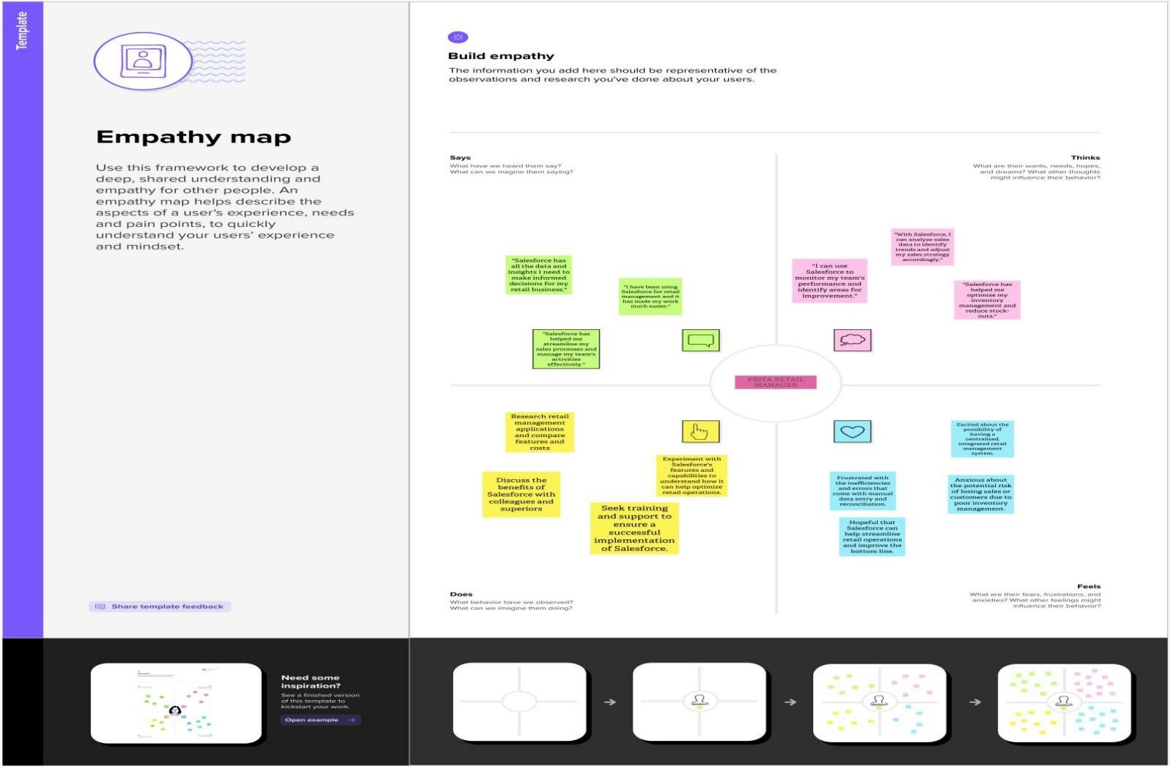

2.2 IDEATION AND BRAINSTORMING MAP

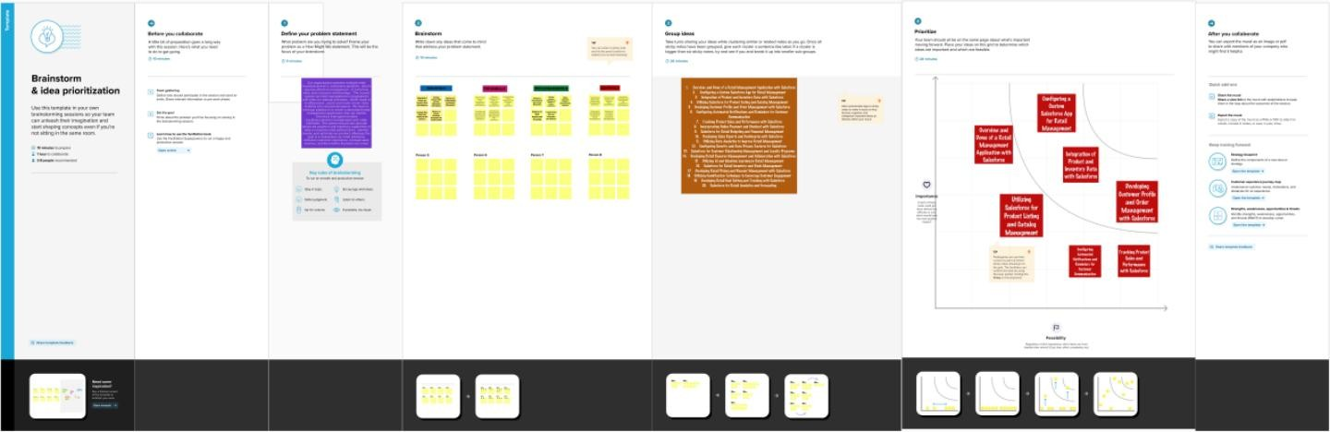

1. **RESULT**

3.1 DATA MODEL

APPLICATION: SALES APP

|  |  |  |
| --- | --- | --- |
| S.NO | OBJECT NAME | DESCRIPTION |
| 1. | Campaign | We do promotions by using this object |
| 2. | Leads | We capture leads here |
| 3. | Accounts | We capture customers data |
| 4. | Contacts | Employees data of customer |
| 5. | Opportunities | SMB sales orders data |
| 6. | Products | Here we store product details I.e electronic types |
| 7. | Warehouse | We capture stocks data |
| 8. | Sales Order | This is an actual order which has invoice details |
| 9. | Dispatch/Tracking | Orders dispatch related info will be stored here |

3.2 ACTIVITY AND SCREENSHOT

**MILESTONE 1:**

ACTIVITY-1

CREATING DEVELOPER ACCOUNT

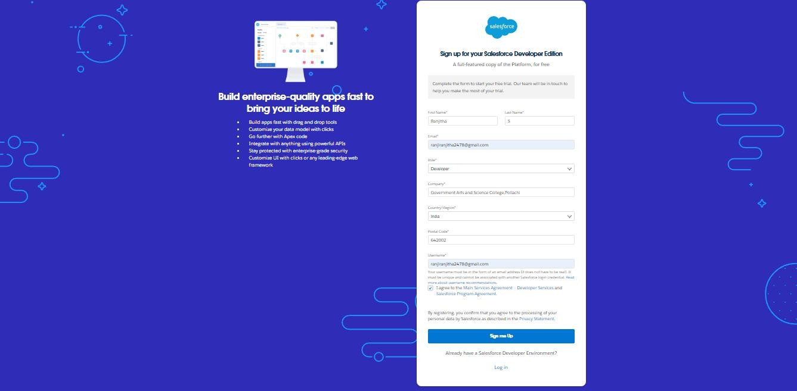

**MILESTONE 2:**

OBJECTS:

ACTIVITY 1

CREATION OF OBJECT DISPLAY/TRACKING

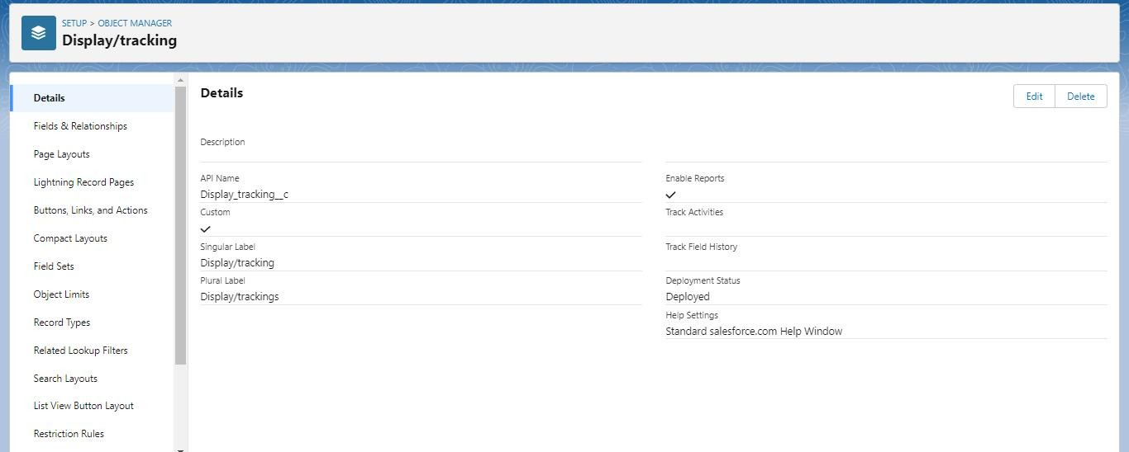CREATION OF OBJECT WAREHOUSE

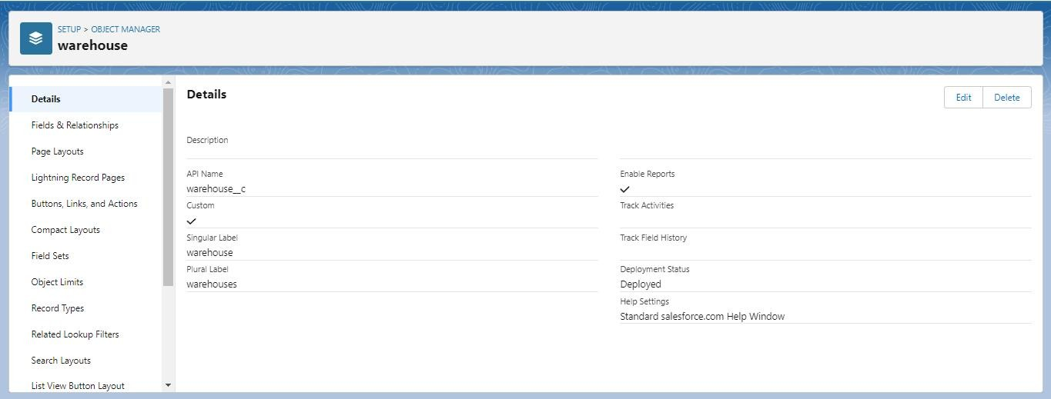

CREATION OF OBJECT WAREHOUSET

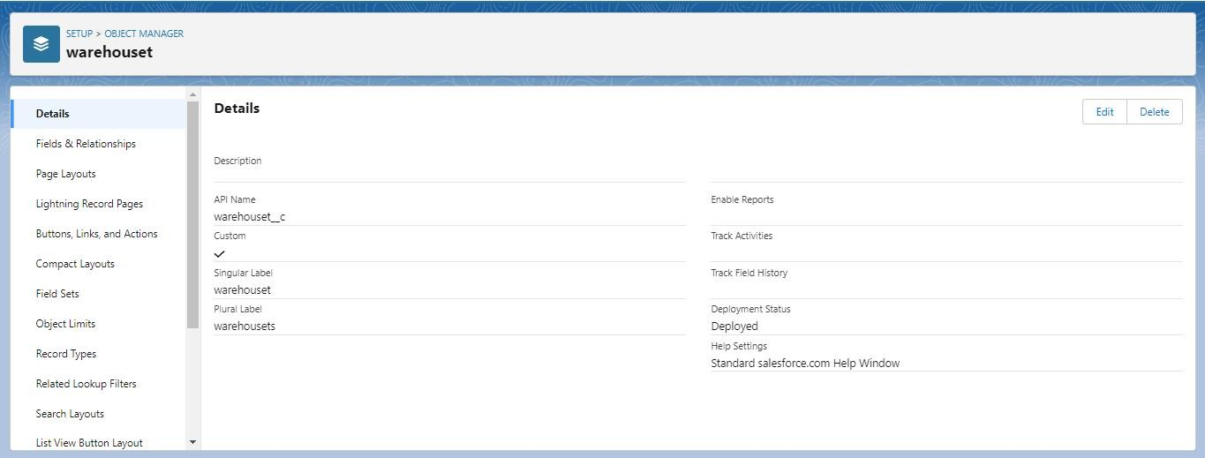

CREATION OF OBJECT SALES ORDER

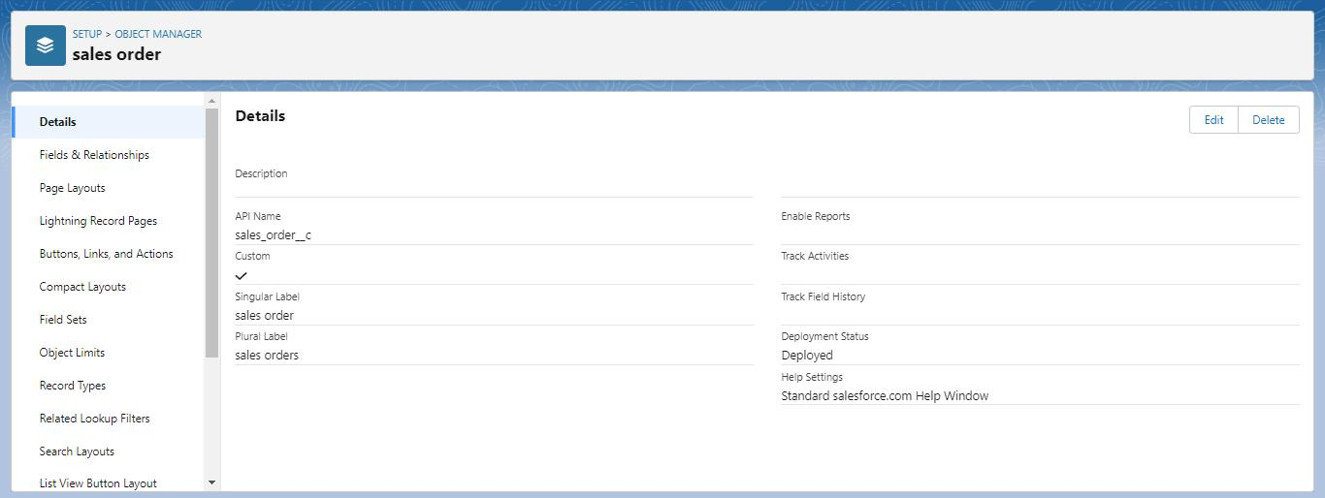

CREATION OF OBJECT LEADS

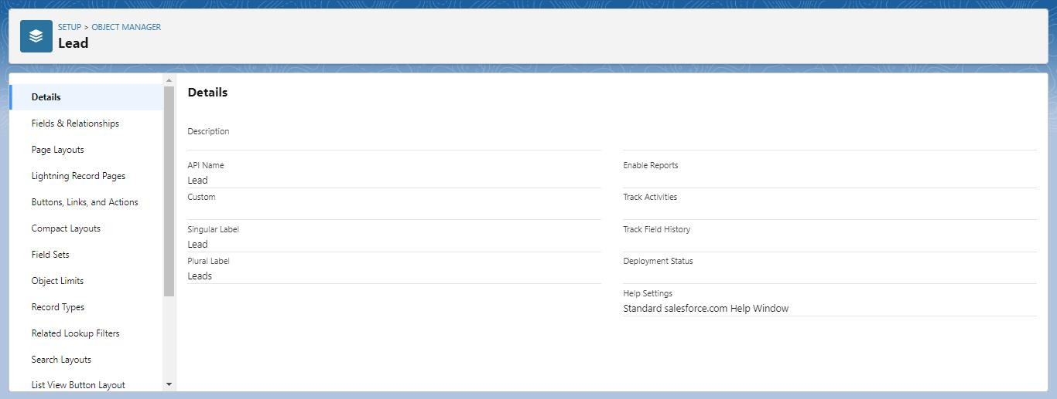2:

ACTIVITY 2:

CREATION OF FIELDS ON DISPATCH/TRACKING

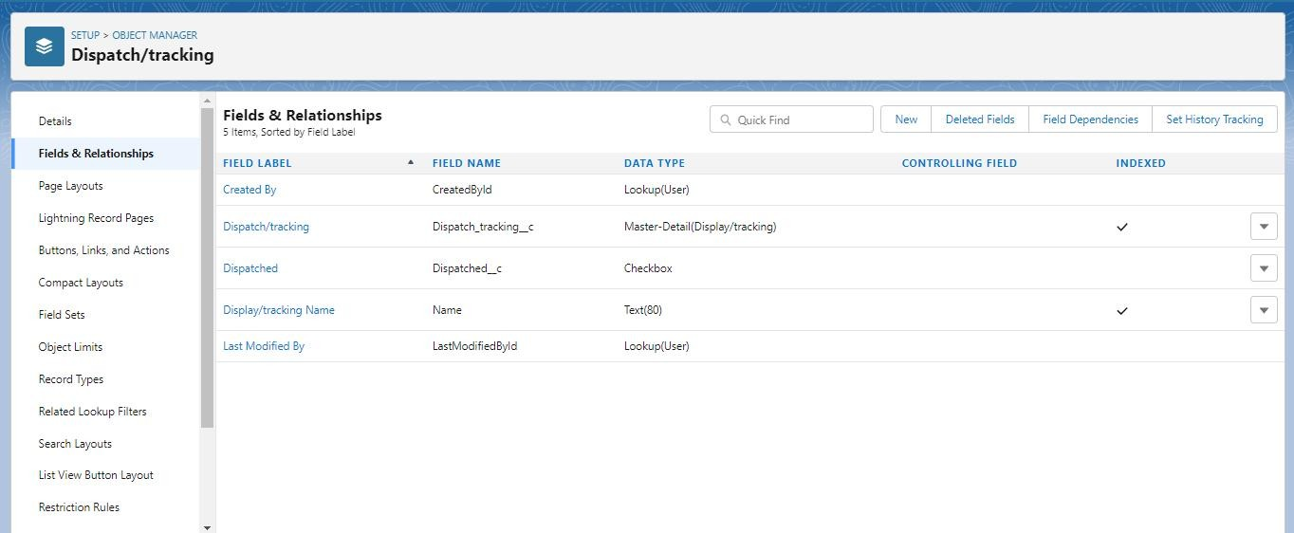

**MILESTONE 3:**

ACTIVITY 1:

CREATION OF RELATIONSHIPS BETWEEN OBJECTS

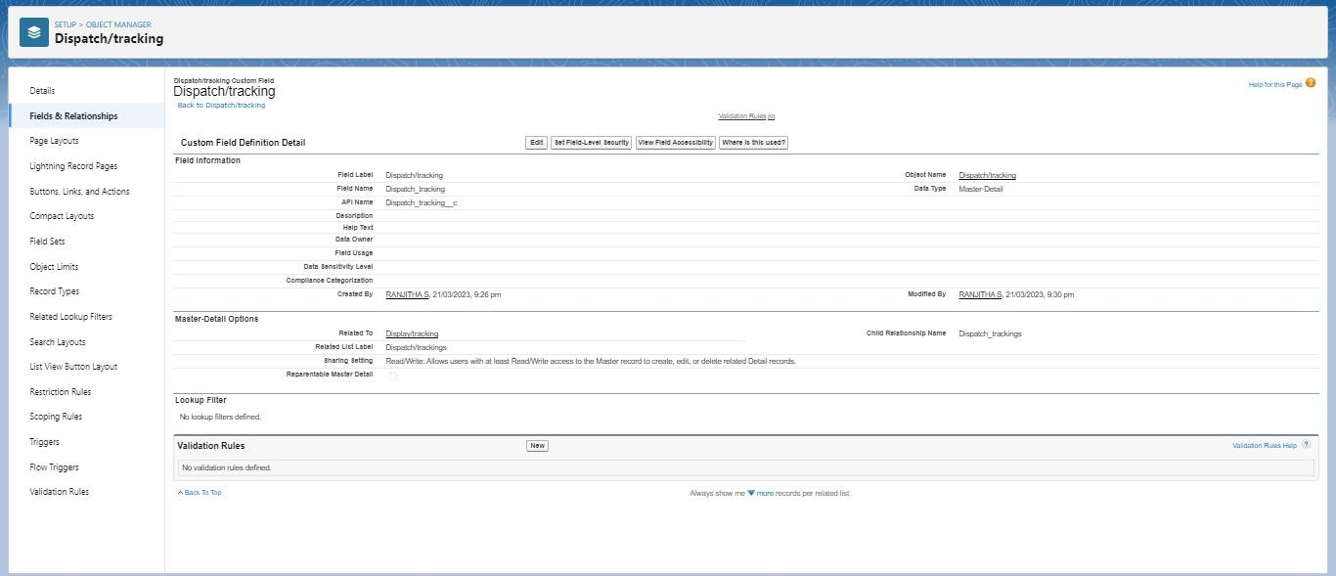**MILESTONE 4**:

APPLICATION

CREATION OF APPLICATION

APP DETAILS AND BRANDING

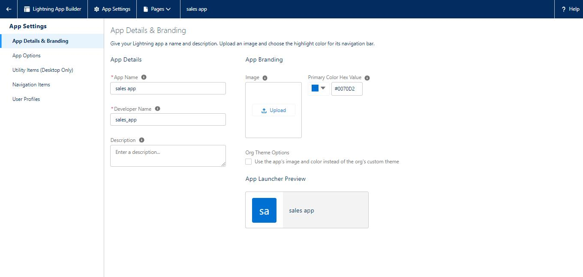

APP OPTIONS

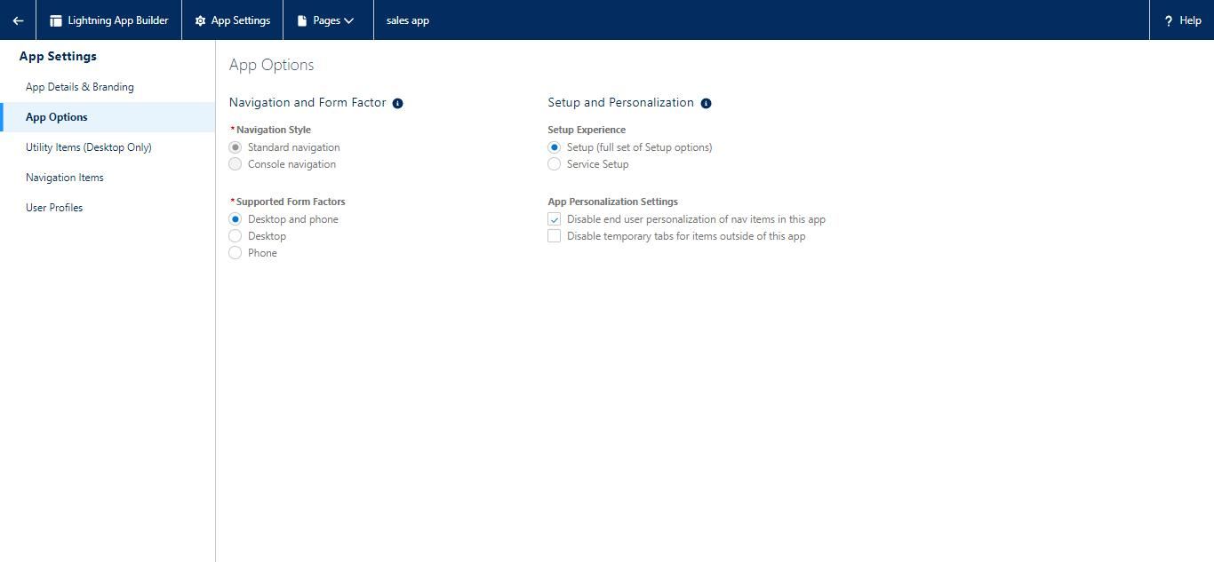

UTILITY ITEMS (DESKTOP ONLY)

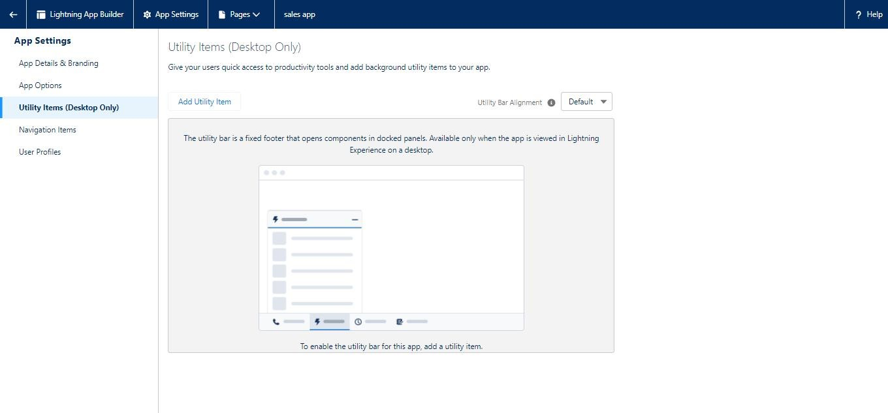

NAVIGATION ITEMS

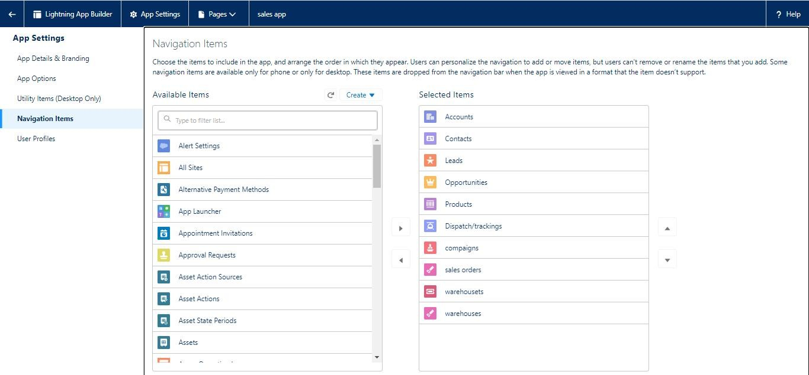

USER PROFILES

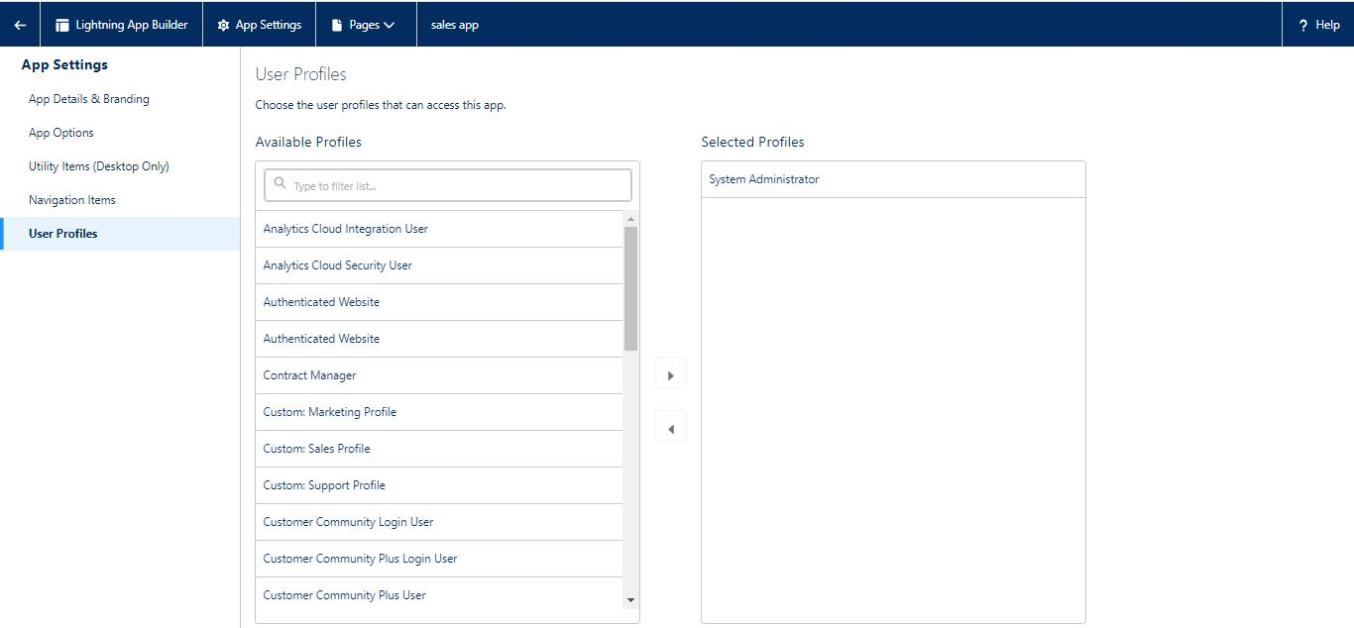

**MILESTONE 5:**

LAYOUTS

CREATION OF CUSTOM TABS

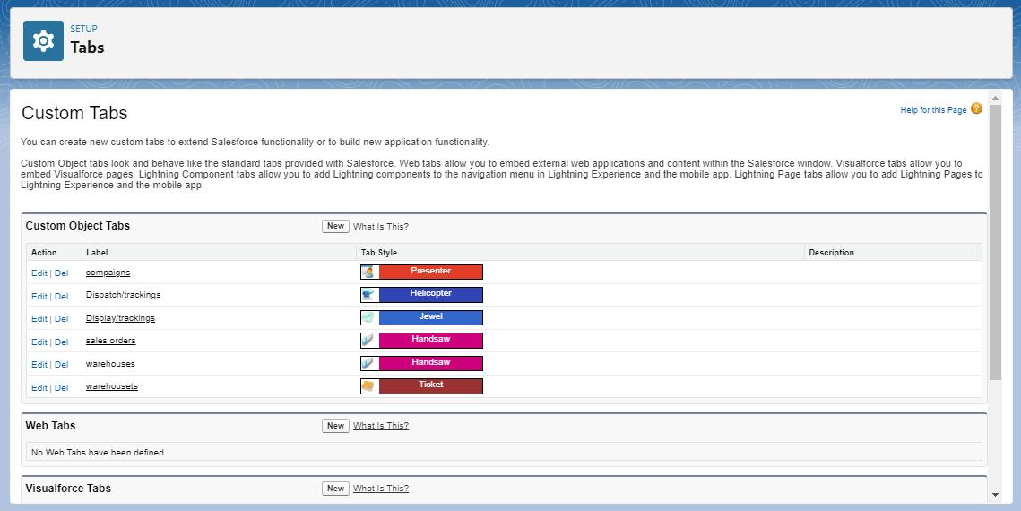

**MILESTONE 6:**

USER

CREATION OF USER

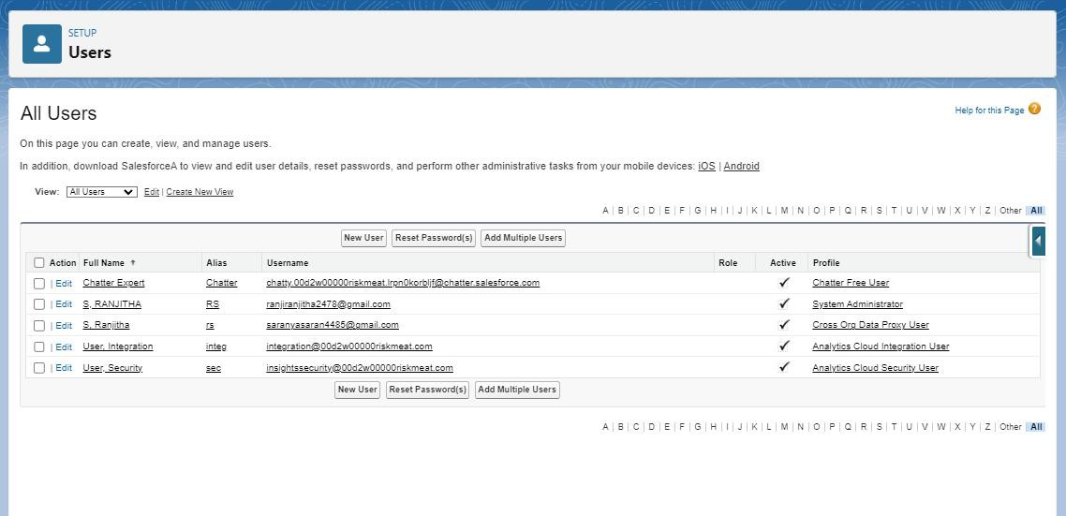

**MILESTONE 7:**

VALIDATION RULES

ACTIVITY 1

CREATION OF VALIDATION RULE

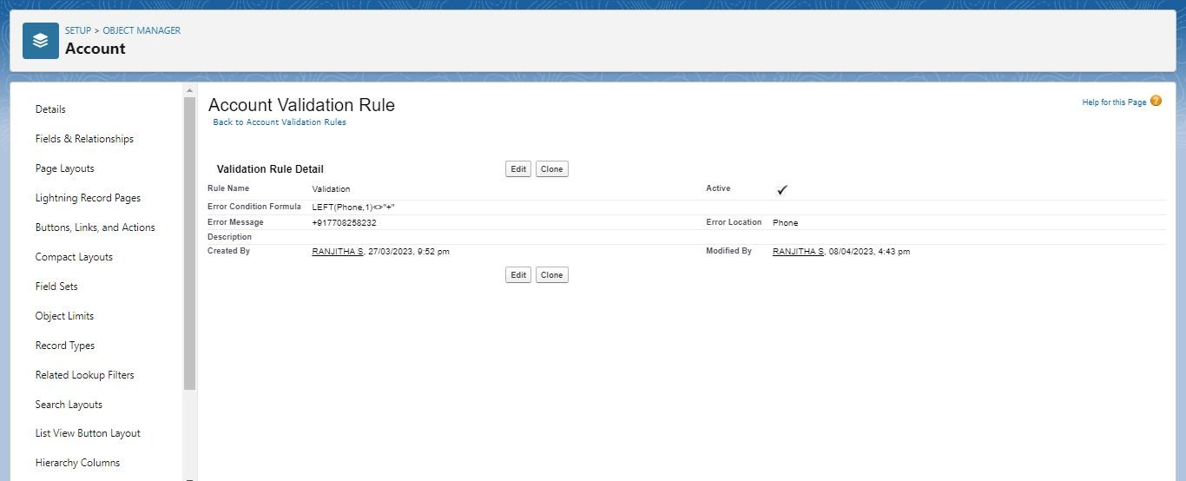ACTIVITY 2

CROSS OBJECT FORMULA

CREATION OF CROSS OBJECT

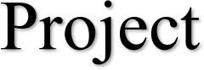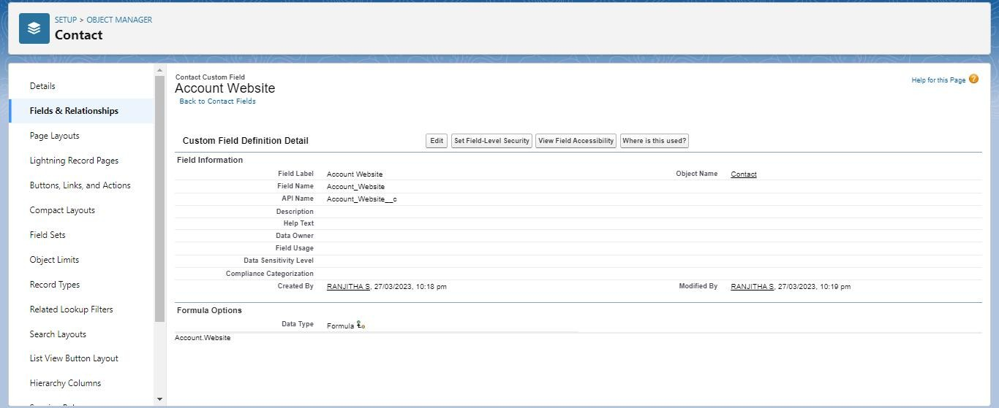

**MILESTONE 8:**

REPORTS

CREATION OF REPORT

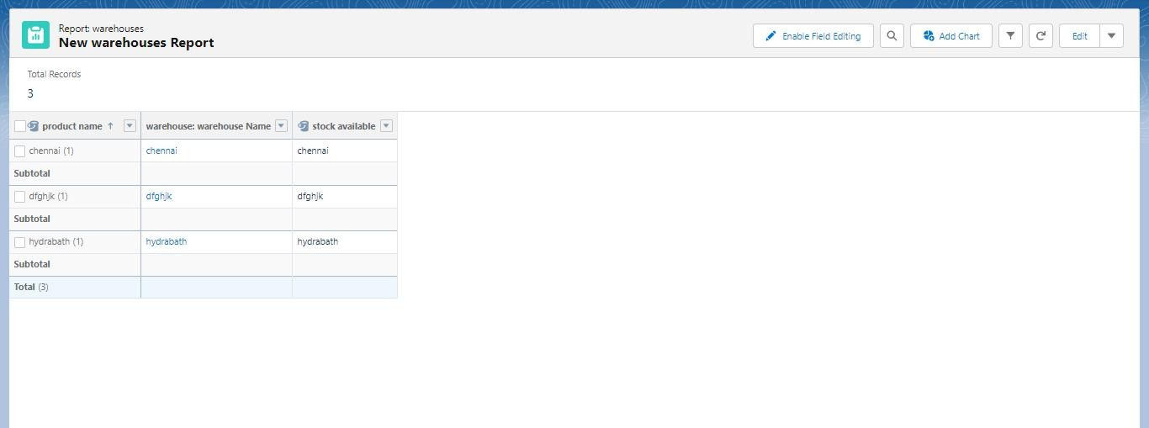

**MILESTONE 9:**

DASHBOARD

CREATION OF DASHBOARD

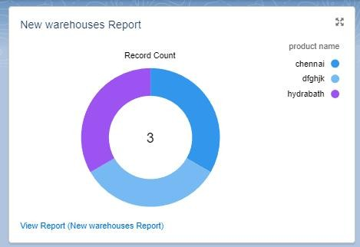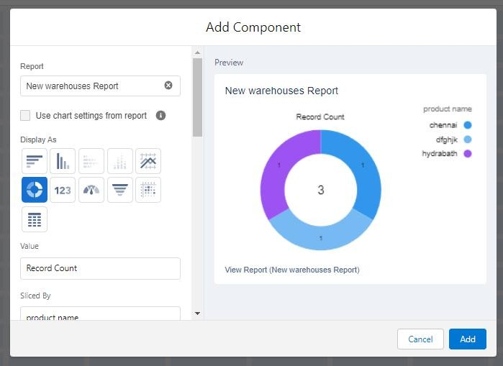

# TRAILHEAD PRIFILE PUBLIC URL

Team Lead - <https://trailblazer.me/id/hgahlot3>

Team Member 1 - <https://trailblazer.me/id/hgahlot3>

Team Member 2 - <https://trailblazer.me/id/hgahlot3>

Team Member 3 – <https://trailblazer.me/id/hgahlot3>

# **5.ADVANTAGES AND DISADVANTAGES**

ADVANTAGES OF GOOD RETAIL MANAGEMENT

### CUSTOMER SATISFACTION

### The biggest advantage of retail management is customer satisfaction. Efficacious planning and management prevent the situation where the customers need to be kept waiting. Even if there are a lot of people in the store, as in the case of festivities, managing the orders is the key to success. It is the task of the retail manager to ensure that the customer executives assist the customers and attend to everyone properly.

### HASSLE-FREE SHOPPING

### It helps the customers to find all the products easily in the

### store. All the products are arranged properly by categorizing them according to their price, quantity, brand, etc, so the customers can easily find the desired products in no time. The retailers won’t even need to get up and fetch the product for their customers. Just the way a customer feels satisfied after a good shopping experience, it also helps in saving the retailer’s time.

3.PREVENTS UNNECESSARY CHAOS AND SHOPLIFTING ACTIVITIES

Proper Retail Management prevents a lot of unnecessary crowding and chaos in the shop. The customers enter, pick up their favorite products, pay the bills and leave with a smile. That’s an example of effective retail management. This kind of management also keeps a check on the shoplifters.

### 4.PROPER ACCOUNTING

When the retailer maintains a database where everything from all that was brought into the shop for sale to all that was sold is mentioned, it makes the daily calculations and accounting less complicated and accurate.

5.WELL-ORGANIZED STORE AND INVENTORY MANAGEMENT

In case of proper retail management, various shelves on which the different categories of the products are placed, are well labeled. This allows the buyers to locate the products all by themselves. Furthermore, it ensures that the shop is well stocked. The customers should never be told that a particular product is out of stock at any point in time as that allows them to go to other stores.

**DISADVANTAGES OF RETAILERS**

The main disadvantages of retailers can be described as follows:

1. HIGH MARKETING COST

Retailers should make investment in decoration of shop and display of goods to attract more customers. So, it requires more marketing or advertising cost than wholesalers.

## SELLING SKILL REQUIRED

It requires good selling skill to attract customers. Retailers should possess the art of good communication and convincing power to influence consumers.

## VERY HIGH COMPETITION

Another disadvantage of retailing is that there is tough competition in the market because several retailers sell similar types of products. So, it is difficult to remain in the competitive environment.

## NO ECONOMIES OF BUYING

Retailers buy small volume of products from wholesalers. So, they miss the opportunity to enjoy he benefit of economies of buying.

1. IT REQUIRES PROPER LOCATION

## It is difficult to find out proper location to start retail store. It requires highly dense area with fewer Competitors.

1. **APPLICATION**

Retail management software is technology that helps business owners drive more sales with applications that include point of sale features, inventory management, retail customer relationship management and more. These solutions often include hardware for payment terminals and can support mobile devices.

Enables in-depth structure and organization of inventory management, often broken into assigned stock keeping units (SKUs). Provides analytics for pinpointing purchasing trends. Interacts between multiple stores to create one master merchandise repository.

1. **CONCLUSION**

It takes work to run a retail store. However, these tips can help you set up your store for long-term success. As a result, you can improve your profit margin while providing better customer service. To provide a top-notch shopping experience, ensure that you consider the needs of your customers and your retail outlet.

# **FUTURE SCOPE**

The retail sector in the country is currently booming, providing plenty of career prospects for people with a passion for sales marketplaces, business diversification, campaigning, advertising, market research, and segmentation. With the continuous expansion of the retail industry, there is a growing demand for retail courses that will prepare students to cope with the tactics, procedures, and methods that will help them generate more sales and customer satisfaction.

Retail management has become one of the fastest-growing occupations in the industry as the economy has grown significantly. The retail industry in India is the most appealing and fastest-growing in the world, demanding an increase in competent expertise in this discipline.

It intends to create a new generation of international-caliber smart retail experts by providing them with global best practices.

**THANK YOU**